Proposed Approach (25%) - Veena

3. Methods & Materials

3.1 Proposed Approach

PM₂.₅ forecasting was formulated as a multivariate, multi-step time-series problem, using historical air-quality, meteorological and temporal information to predict future PM₂.₅ concentrations at London Marylebone Road. The study evaluated 7-, 14- and 30-day forecasting horizons, where each horizon represents the complete future trajectory rather than only the final day. A 30-day historical input window was used consistently, allowing the models to incorporate recent pollution persistence and longer-term temporal patterns. The modelling framework comprised Random Forest, XGBoost, LSTM, GRU, CNN-LSTM and Transformer models. The LSTM and GRU architectures formed the primary deep-learning contribution. Combining pollutant and meteorological predictors is supported by previous air-quality forecasting research, which identifies these as important predictor categories (Méndez, Merayo and Núñez, 2023).

3.2 Data Acquisition and Pre-processing

PM₂.₅ data was collected from the London Marylebone Road AURN station through the DEFRA UK-AIR service, covering April 2022 to December 2024. Auxiliary pollutants (PM₁₀, NO, NO₂, NOₓ, O₃, CO) were obtained for the same site and period. Meteorological variables such as temperature, humidity, wind speed and direction, precipitation and atmospheric pressure were sourced from the Met Office via the CEDA archive.

Before modelling, a data-quality audit was carried out to check for missing values, gaps, duplicates and outliers. The post-April 2022 period was selected as it offered much better data completeness. Short gaps were filled using linear interpolation, with any remaining missing values replaced using a same-weekday rolling mean to keep weekly patterns intact. Extreme values were flagged using a 3×IQR rule but kept where they looked like genuine pollution episodes.

Hourly readings were then aggregated to daily averages to give a consistent dataset for forecasting. Historical features were built from this daily series, including PM₂.₅ lags at 1, 2, 3, 7, 14 and 30 days, plus rolling means, standard deviations and rate-of-change features across several windows. All transformations were calculated using training data only, so no future information could leak into the model inputs.

3.3 Feature Engineering

Feature engineering was designed to represent the principal temporal and environmental drivers of PM₂.₅. Historical PM₂.₅ features included lags of 1, 2, 3, 7, 14 and 30 days, together with rolling means, standard deviations, minima and maxima over multiple windows. Rate-of-change and trend features were also generated to represent the direction and variability of recent pollution conditions. The use of historical trend information is consistent with previous PM₂.₅ forecasting research (Wood, 2024).

Auxiliary pollutants were incorporated because related pollutants can provide information about shared emission sources and atmospheric processes. Meteorological variables were included because wind, temperature, humidity, precipitation and pressure influence pollutant dispersion, accumulation and removal (Méndez, Merayo and Núñez, 2023). Calendar variables including month, weekday, day of year, week and season were also constructed. Cyclical sine/cosine transformations were applied to periodic variables so that temporal boundaries such as December–January were represented continuously.

All lagged and rolling features were calculated using historical observations only, ensuring that information from the future forecast period could not enter the model inputs.

Table 1. Experimental configuration

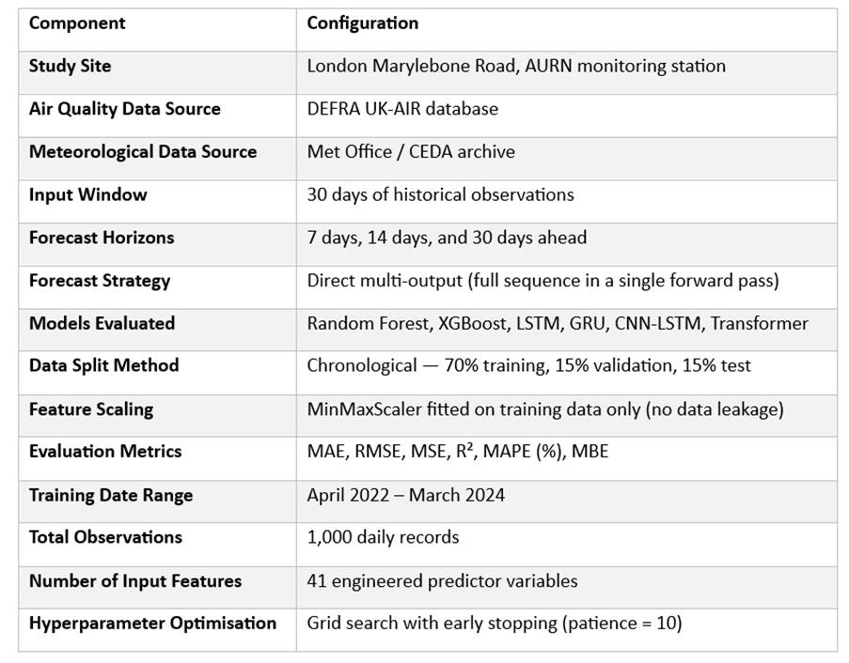

3.4 Forecast Formulation and Model Development

For each forecasting origin, the models received the previous 30 days of observations as the input sequence, containing engineered predictor variables including lagged PM₂.₅ values, rolling statistics, meteorological variables, and temporal features. Three forecasting tasks were considered: predicting the next 7, 14, and 30 days ahead. The 30-day input window refers to the historical information provided to the model at each origin and is distinct from the forecast horizon, which defines how far ahead predictions are generated.

A direct multi-output forecasting strategy was adopted. Rather than predicting one day ahead and recursively feeding predictions back as inputs, each model generated the complete future sequence in a single forward pass. For example, the 7-day model produced predictions for Days 1 through 7 simultaneously, while the 30-day model produced predictions for Days 1 through 30. This approach avoids the accumulation of prediction errors associated with recursive forecasting strategies (Ben Taieb, Sorjamaa and Bontempi, 2010).

Six model architectures were investigated: Random Forest, XGBoost, LSTM, GRU, CNN-LSTM, and Transformer. Random Forest was included as a tree-based baseline capable of modelling nonlinear relationships without sequential assumptions. XGBoost was selected for its strong performance on structured datasets and ability to capture complex feature interactions. LSTM was chosen for its gated memory mechanism, enabling the model to retain relevant information across the 30-day input sequence (Hochreiter and Schmidhuber, 1997). GRU was included as a computationally lighter recurrent alternative (Cho et al., 2014). CNN-LSTM combined convolutional layers for local pattern extraction with LSTM layers for temporal dependency modelling. The Transformer was included for its self-attention mechanism, which captures relationships across the full input sequence without relying on sequential processing.

All models used the same 30-day input window and were evaluated across the 7-, 14- and 30-day forecasting horizons, providing a consistent basis for comparison across architectures and forecast lengths.

3.5 Experimental Design and Evaluation

The dataset was divided chronologically into training, validation and held-out test periods to reflect the intended real-world forecasting scenario, where future observations are unavailable during model development. The Marylebone Road test dataset was reserved exclusively for final evaluation and was not used for model selection or tuning. MinMax scaling was fitted only on the training data before being applied to the validation and test sets, preventing information from unseen observations influencing the models.

All model architectures were evaluated using the same 7-, 14- and 30-day forecasting horizons. Performance was assessed using Mean Absolute Error (MAE), Root Mean Squared Error (RMSE), Mean Squared Error (MSE), coefficient of determination (R²), Mean Absolute Percentage Error (MAPE) and Mean Bias Error (MBE). MAE provides an interpretable measure of average prediction error, while RMSE and MSE place greater emphasis on larger errors. R² measures the proportion of variance explained by the model, while MBE identifies systematic over- or under-prediction. MAPE was treated as a supplementary metric because percentage-based errors can become unstable when observed PM₂.₅ concentrations are close to zero.

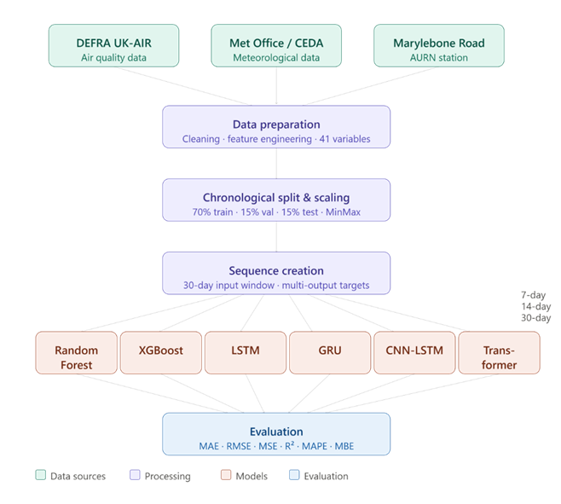

Figure ( ) Data processing and forecasting pipeline

Performance was assessed both across individual forecast steps and across complete forecast horizons, allowing changes in error as the prediction distance increased to be examined. Permutation feature importance was also applied as a model-agnostic interpretability method to investigate the relative contribution of the input variables.

3.6 Agile Development Methodology

The modelling pipeline was developed using an iterative Agile methodology, enabling our team to progressively develop, test and refine the forecasting system. Development was organised into sprints, with regular stand-up meetings used to communicate progress, identify blockers and coordinate responsibilities. Wider team meetings supported decisions affecting the shared dataset, feature engineering, model integration and evaluation framework.

This iterative approach was appropriate because the stages of the project were interdependent. For example, changes to data preprocessing or feature engineering could affect the input structure and subsequently require model adjustments. Incremental development allowed these issues to be identified and addressed throughout the project rather than relying solely on decisions made at the outset.

Git and GitHub were used for version control and collaborative development, allowing changes to be tracked, reviewed and integrated as model components were developed. The shared repository also provided traceability and reduced the risk of conflicting versions of the forecasting pipeline.

Overall, the combination of sprints, stand-ups, pair programming and Git/GitHub provided a structured but flexible process for refining the forecasting methodology throughout development.

Experimental Results: Discussions and Conclusions (20%) - Matt

5 Experimental Results

5.1 Setup and Evaluation Protocol

The dataset was assembled from various publicly available sources (DEFRA, no date, 2026; Met Office, 2025a, 2025b, 2026a; Met Office et al., 2026b). London Marylebone Road with meteorological data drawn from nearby stations was used as the primary study region for our analysis due to its reliable and comprehensive air quality data. Pooled-path evaluation was conducted on differing long horizons to assess model performance across the full range of the horizons, alongside a single lead day evaluation. Creating a dataset with 1,364 days of observations, we used a daily temporal resolution for our analysis to avoid noise from short-term fluctuations. A series of metrics were utilized to evaluate model performance (MAE, MSE, RMSE, R², MAPE, MBE) to ensure a comprehensive comparison of model accuracy and reliability. Furthermore, persistence and climatology baselines were used to benchmark the performance of the six models in comparison to a continuation of the origin observation and seasonal averages (EPA, 2003). Mean Bias Error (MBE) was included on public health grounds to quantify systematic over or under prediction by the models, the more dangerous bias being under-prediction of PM2.5 concentrations.

5.2 Model Comparison

Table 1. Forecast accuracy by model and horizon, with persistence and day-of-year climatology baselines.
Model | Horizon (days) | Evaluation | MAE | RMSE | MSE | R2 | MAPE (%) | MBE | MAE vs persistence (%) | RMSE vs persistence (%)
Persistence | 1 | lead_1 | 3.124 | 5.674 | 32.191 | 0.374 | 37.6 | 0.0 | 0.0 | 0.0
Random Forest | 1 | lead_1 | 3.154 | 5.102 | 26.03 | 0.494 | 41.4 | 0.064 | -0.9 | 10.1
XGBoost | 1 | lead_1 | 3.155 | 5.173 | 26.762 | 0.48 | 40.9 | -0.022 | -1.0 | 8.8
CNN-LSTM | 1 | lead_1 | 3.166 | 4.88 | 23.813 | 0.475 | 42.1 | 0.124 | -1.3 | 14.0
Transformer | 1 | lead_1 | 4.364 | 6.773 | 45.875 | -0.011 | 56.9 | -0.178 | -39.7 | -19.4
Climatology | 1 | lead_1 | 4.675 | 7.344 | 53.938 | -0.049 | 56.9 | -0.613 | -49.6 | -29.4
CNN-LSTM | 7 | pooled_path | 3.827 | 6.393 | 40.866 | 0.106 | 45.0 | -1.063 | 21.6 | 20.1
XGBoost | 7 | pooled_path | 4.03 | 6.347 | 40.281 | 0.224 | 49.8 | -0.419 | 17.5 | 20.7
Random Forest | 7 | pooled_path | 4.062 | 6.27 | 39.315 | 0.243 | 51.4 | -0.238 | 16.8 | 21.6
GRU | 7 | pooled_path | 4.136 | 6.521 | 42.523 | 0.18 | 48.1 | -0.969 | 15.3 | 18.5
LSTM | 7 | pooled_path | 4.321 | 7.085 | 50.193 | 0.032 | 47.4 | -1.391 | 11.5 | 11.5
Transformer | 7 | pooled_path | 4.563 | 6.485 | 42.057 | 0.08 | 64.8 | 0.684 | 6.6 | 19.0
Climatology | 7 | pooled_path | 4.688 | 7.38 | 54.46 | -0.049 | 56.9 | -0.603 | 4.0 | 7.8
Persistence | 7 | pooled_path | 4.884 | 8.002 | 64.039 | -0.233 | 60.2 | 0.03 | 0.0 | 0.0
CNN-LSTM | 14 | pooled_path | 3.912 | 6.648 | 44.198 | 0.028 | 45.8 | -1.068 | 26.7 | 22.6
GRU | 14 | pooled_path | 4.049 | 6.82 | 46.508 | 0.1 | 42.2 | -1.746 | 24.1 | 20.6
XGBoost | 14 | pooled_path | 4.192 | 6.617 | 43.779 | 0.149 | 50.9 | -0.586 | 21.4 | 23.0
Random Forest | 14 | pooled_path | 4.205 | 6.501 | 42.269 | 0.179 | 52.4 | -0.367 | 21.2 | 24.3
Transformer | 14 | pooled_path | 4.231 | 6.701 | 44.903 | 0.012 | 54.9 | -0.254 | 20.7 | 22.0
LSTM | 14 | pooled_path | 4.415 | 7.387 | 54.564 | -0.056 | 47.1 | -1.665 | 17.2 | 14.0
Climatology | 14 | pooled_path | 4.652 | 7.31 | 53.437 | -0.038 | 57.0 | -0.511 | 12.8 | 14.9
Persistence | 14 | pooled_path | 5.334 | 8.594 | 73.854 | -0.435 | 64.5 | 0.063 | 0.0 | 0.0
CNN-LSTM | 30 | pooled_path | 4.16 | 6.638 | 44.061 | -0.03 | 55.7 | -0.168 | 21.6 | 21.8
XGBoost | 30 | pooled_path | 4.275 | 6.794 | 46.152 | 0.071 | 52.3 | -0.607 | 19.4 | 19.9
LSTM | 30 | pooled_path | 4.282 | 7.186 | 51.632 | -0.036 | 47.4 | -1.446 | 19.3 | 15.3
Random Forest | 30 | pooled_path | 4.334 | 6.712 | 45.05 | 0.093 | 54.6 | -0.338 | 18.3 | 20.9
Transformer | 30 | pooled_path | 4.436 | 6.353 | 40.358 | 0.056 | 66.0 | 0.989 | 16.4 | 25.1
GRU | 30 | pooled_path | 4.495 | 7.18 | 51.551 | -0.034 | 51.4 | -1.444 | 15.3 | 15.4
Climatology | 30 | pooled_path | 4.528 | 7.157 | 51.219 | -0.031 | 56.7 | -0.417 | 14.7 | 15.7
Persistence | 30 | pooled_path | 5.307 | 8.486 | 72.006 | -0.45 | 65.6 | 0.372 | 0.0 | 0.0

The above table shows a distinct performance difference among the models across various evaluation horizons and metrics. Persistence has the lowest 1-day MAE (3.124) and MAPE (37.6%). Across the 7, 14 and 30 day horizons the CNN-LSTM consistently outperforms the persistence baseline and other models on the MAE metric (3.827, 3.912 and 4.160 µg/m³). The MAPE is lowest for the CNN-LSTM at 7 days, for the GRU at 14 days (42.2%), and for the LSTM at 30 days (47.4%). Random Forest achieves the highest R² values across all horizons including 1 day (0.494, 0.243, 0.179, 0.093). Furthermore, it performed best on the RMSE metric at 7 and 14 days, while CNN-LSTM performed best at 1 day and the Transformer model performed best at 30 days. The differences in these metrics can be explained by the typical-day versus extreme-day trade-off (Lee et al., 2024; Wood, 2024). The CNN-LSTM under-predicts at 7 and 14 days (MBE −1.063 and −1.068 µg/m³), which decreases the MAE as most of our samples sit in a moderate concentration range. However, this comes at the cost of underestimating higher concentration events, creating a higher RMSE in comparison to the Random Forest model which better captures the tail of the distribution. From 7 days onward every model beats persistence on MAE by 6.6–26.7%.

5.3 Skill against the baseline

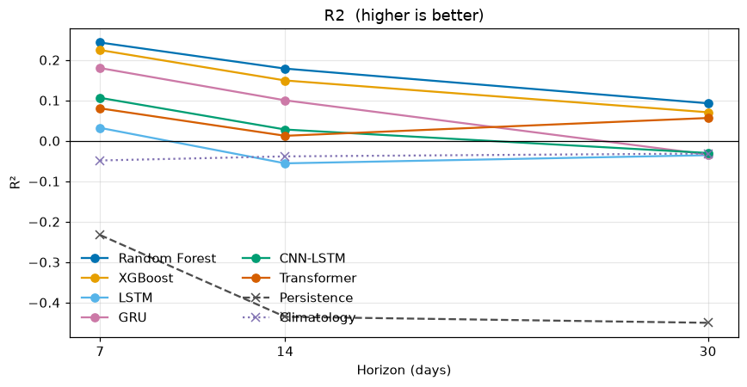
Fig. 1. R² by pooled-path horizon for the six models, persistence and climatology.
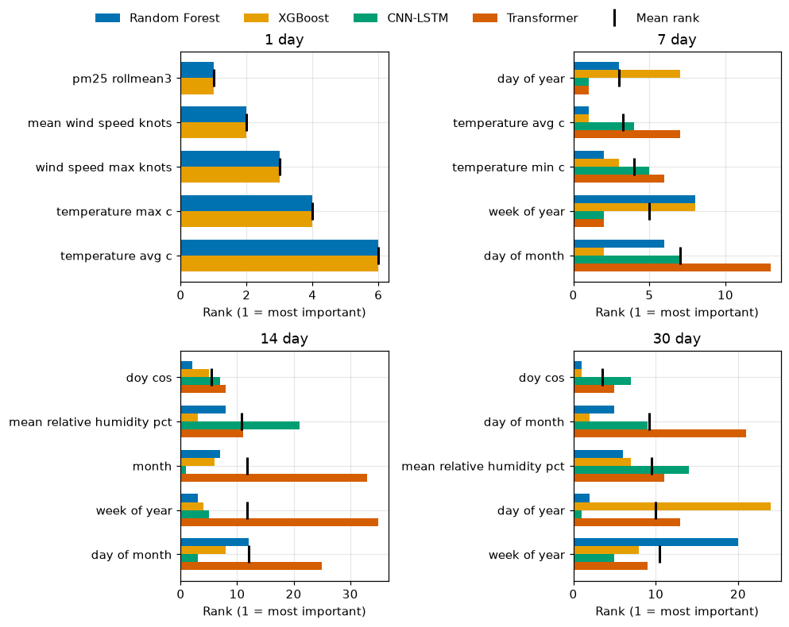
Fig. 2. Mean permutation importance rank of the leading features at 1, 7, 14 and 30 days.

Fig. 1 shows R² at 7, 14 and 30 days. Persistence R² is negative throughout, worsening from −0.23 at 7 days to −0.45 at 30 days, which means it performs worse than a simple mean prediction. MAE improvement over that baseline is therefore a weak claim of skill. The day-of-year climatology is a second reference, the training mean PM2.5 for each calendar day, and its R² is slightly negative at every pooled horizon, so even a seasonal mean does not beat the test-year average. The machine-learning models beat that climatology at 7 days and then close on it . By 30 days CNN-LSTM, GRU and LSTM have negative R² and sit on the climatology line, while Random Forest, XGBoost and the transformer remain above it. The best R² is still only 0.093 (Random Forest), a 9% reduction in mean squared error relative to predicting the mean of the observations. A further observation is the shift in feature importance (Zeng et al., 2026) over time across models (Fig. 2), with recent PM2.5 and wind at 1 day, temperature and calendar by 7 days, calendar and humidity together at 14 days, and calendar by 30 days, with humidity remaining in the ranking. Within Random Forest the leading permutation score collapses from 0.824 to 0.067 .

5.4 Accuracy is not the same as reliability

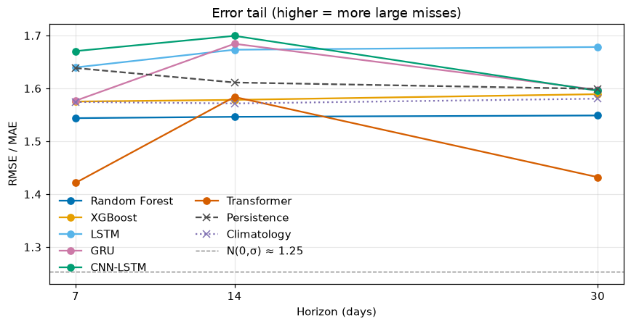
Fig. 3. RMSE/MAE ratio by pooled-path horizon, with the Gaussian reference at 1.25.

The RMSE/MAE ratio sits well above the Gaussian reference of 1.25 at every pooled horizon (Fig. 3), so large errors weigh more on RMSE than they would under Gaussian noise. Random Forest is the flattest series across 7, 14 and 30 days , and the lowest among models that remain competitive on MAE. Transformer is lower at 7 and 30 days, but its 7-day MAE is the worst of the six ML models (4.563 ), so the low ratio reflects uniformly poor accuracy rather than reliability. At 14 days the typical-day versus extreme-day split is clear. Models with |MBE| above 1 (CNN-LSTM, LSTM, GRU) have higher ratios than those with |MBE| below 0.6 (Random Forest, XGBoost, Transformer). That split is present throughout for LSTM while CNN-LSTM demonstrates the link. When its MBE shrinks to −0.168 at 30 days, the ratio falls with it.

Bias refers to under or over prediction of PM2.5, measured here by MBE.
Tail refers to large errors, and the RMSE/MAE ratio measures how much of the total error comes from them.

6 Discussion

6.1 No single best model

No single model performs best across all horizons and metrics. Rankings change depending on the metric (Section 5.2) because of the typical-day versus extreme-day trade-off. Shrinking predictions low (MBE) wins the MAE on most days but damages performance on extreme events by concentrating errors in the tail of the distribution (RMSE/MAE ratio). Selecting solely on MAE therefore risks the under-prediction of PM2.5, which Section 5.1 used MBE to flag. Random Forest never leads on MAE but it is among the least biased at every horizon, has the flattest RMSE/MAE ratio, and the highest R² values, making it the most balanced model overall.

6.2 Where skill exists and where it doesn't

Skill is concentrated at short range and largely gone by a month (Sun et al., 2021; Zeng et al., 2026) (Section 5.3). At 1-day lead, Random Forest reaches R² 0.494 and even persistence has R² 0.374. On the pooled path that skill then falls: the best R² is 0.243 at 7 days, 0.179 at 14 days, and 0.093 at 30 days, where three of the six models sit below a constant mean. Permutation importance matches that decay independently. At 1 day the leading inputs are recent PM2.5 (pm25_rollmean3) and wind, whereas by 30 days calendar leads, recent PM2.5 has left the ranking, and humidity is what remains. The limited long-horizon R² in Section 5.2 is therefore not only a scoring result. The models have shifted from tracking the last few days to a calendar-driven estimate.

6.3 What the forecast actually delivers
The forecasts support a graded set of uses, not one claim of skill. At 1 day there is real skill (Section 6.2), enough for daily alerts. Through 7 days and into 14 days the better models still beat a constant mean, enough for week-ahead advisory planning, not a precise daily peak (Section 6.1). By 30 days typical-day error has moved toward the day-of-year climatology alongside a seasonal feature importance shift, with recurrent models collapsing onto the climatology reference and non-recurrent models keeping a small but measurable advantage. That is the proposal’s long-range product, broader trend rather than short-term fluctuation, and the recurrent models do converge to it. What it did not anticipate is how little that trend is worth here. Even the day-of-year climatology has negative R², so a seasonal product cannot carry the daily public-health decisions the proposal invoked. Even Random Forest, among the least biased models on MBE, still under-predicts PM2.5 on the 7 to 30-day paths, which on public-health grounds (Section 5.1) limits how far those applications can be pushed.

6.4 Limitations

This analysis was limited to one urban site, London Marylebone Road with meteorological data from nearby Met Office stations. Marylebone was used because it was the most complete station in the extract, after a nationwide sample was dropped due to incompleteness that was too severe for safe imputation. Training is only about 2.7 years for the same reason, Marylebone before 6 April 2022 failing the completeness cut. The test set is one year, so one cycle of weather.

7 Conclusions and Future Work

7.1 Conclusion

No single model consistently won across all horizons and metrics. CNN-LSTM has the lowest MAE at 7, 14 and 30 days, so it is the better typical-day forecast, but we infer that this comes with under-prediction of higher concentrations. Although Random Forest never leads on MAE, it has the highest R² values across all horizons, and the lowest RMSE at 7 and 14 days. For an application where accurate prediction of extreme events is critical, that trade-off makes Random Forest the preferable choice despite not having the lowest MAE. There is skill at short horizons. At a 1-day lead Random Forest reaches R² 0.494, and even persistence has 0.374. On the pooled path the best R² falls to 0.243 at 7 days, 0.179 at 14 days, and 0.093 at 30 days, where CNN-LSTM, GRU and LSTM sit below a constant mean, highlighting the rapid decay of forecast skill with increasing horizon length. Feature importance analysis further supports this, showing that the models rely on recent PM2.5 and meteorological variables at short horizons, but shift to calendar-based features at longer horizons, reflecting the diminishing predictive power of recent observations. Beating our two baselines, persistence and day-of-year climatology, is only a moderate achievement, as both score below the constant mean. This forecast is usable for advisory planning over one to two weeks, not for precise day-by-day forecasts at those horizons, and not at all at a month.

7.2 Future work

Further research could explore utilizing longer historical data. This would allow us to build a climatology baseline that estimated from more than 2 or 3 samples per calendar day. A full decade would allow us to see if the 30 day forecast is limited by the dataset or by the inherent predictability of PM2.5 concentrations. Our single-site analysis used only the London Marylebone Road site, which is an urban, traffic-dominated, high-pollution location, so it is unclear whether the findings generalize to other urban areas or to rural locations (Wood, 2024). Data availability, not the methodology, was the block for that comparison.

References
DEFRA (no date) Data archive. Available from: https://uk-air.defra.gov.uk/data/ [Accessed 27 August 2026].

DEFRA (2026) London Marylebone Road air quality measurements, UK-AIR [online]. Available from: https://uk-air.defra.gov.uk/networks/site-info?site_id=MY1 [Accessed 13 July 2026].

EPA (2003) Guidelines for developing an air quality (ozone and PM2.5) forecasting program. EPA-456/R-03-002. Environmental Protection Agency, Office of Air Quality Planning and Standards. Available from: https://www.airnow.gov/sites/default/files/2020-06/aq-forecasting-guidance-1016.pdf

Lee, Y., Chien, F., Chien, H., Lin, Y. and Sun, M. (2024) Enhancing real-time PM2.5 forecasts: A hybrid approach of WRF-CMAQ model and CNN algorithm. Atmospheric Environment [online]. 338, article no. 120835. Available from: https://doi.org/10.1016/j.atmosenv.2024.120835 [Accessed 31 August 2026].

Met Office (2025a) MIDAS Open: UK hourly weather observation data, NERC EDS Centre for Environmental Data Analysis (v202507) [online]. Available from: https://dx.doi.org/10.5285/99173f6a802147aeba430d96d2bb3099 [Accessed 27 August 2026].

Met Office (2025b) MIDAS Open: UK hourly rainfall data, NERC EDS Centre for Environmental Data Analysis (v202507) [online]. Available from: https://dx.doi.org/10.5285/c75ca7291a5048739010380dce6ebc99 [Accessed 27 August 2026].

Met Office (2026a) MIDAS Open: UK mean wind data, NERC EDS Centre for Environmental Data Analysis (v202607) [online]. Available from: https://dx.doi.org/10.5285/c7393fdc2c974071a2efd7f8601b1bab [Accessed 27 August 2026].

Met Office, Hollis, D., Carlisle, E., Kendon, M., Packman, S. and Doherty, A. (2026b) HadUK-Grid Climate Observations by Administrative Regions over the UK, NERC EDS Centre for Environmental Data Analysis (v1.3.2.ceda) [online]. Available from: https://dx.doi.org/10.5285/386b3c1ee2054ef5ae0d73060963a9f1 [Accessed 27 August 2026].

Sun, H., Fung, J.C.H., Chen, Y., Chen, W., Li, Z., Huang, Y., Lin, C., Hu, M. and Lu, X. (2021) Improvement of PM2.5 and O3 forecasting by integration of 3D numerical simulation with deep learning techniques. Sustainable Cities and Society [online]. 75, article no. 103372. Available from: https://doi.org/10.1016/j.scs.2021.103372 [Accessed 31 August 2026].

Wood, D.A. (2024) Trend-attribute forecasting of hourly PM2.5 trends in fifteen cities of Central England applying optimized machine learning feature selection. Journal of Environmental Management [online]. 356, article no. 120561. Available from: https://doi.org/10.1016/j.jenvman.2024.120561 [Accessed 31 August 2026].

Zeng, L., Dong, R., Yuan, M., Jing, L. and Jiao, S. (2026) Evaluating deep learning time series models for PM2.5 forecasting across diverse horizons. iScience [online]. 29 (2), article no. 114770. Available from: https://doi.org/10.1016/j.isci.2026.114770 [Accessed 31 August 2026].

